Radar Speed Gun
# Source: AI Source: Provided by: [Data Path: Persons Table -> ID Column: 1, Name_En Column: Motasem Essam] -> From: [ChatGPT] on [7/17/2026]
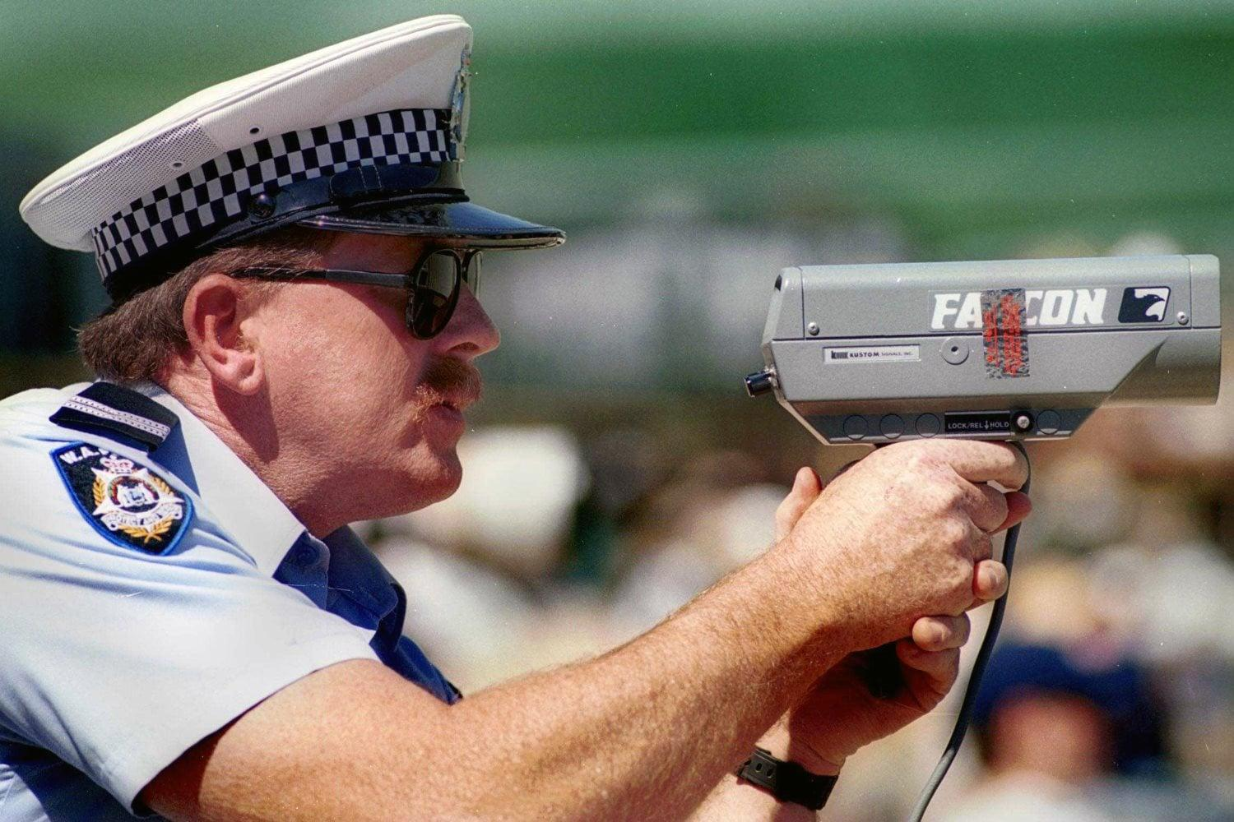
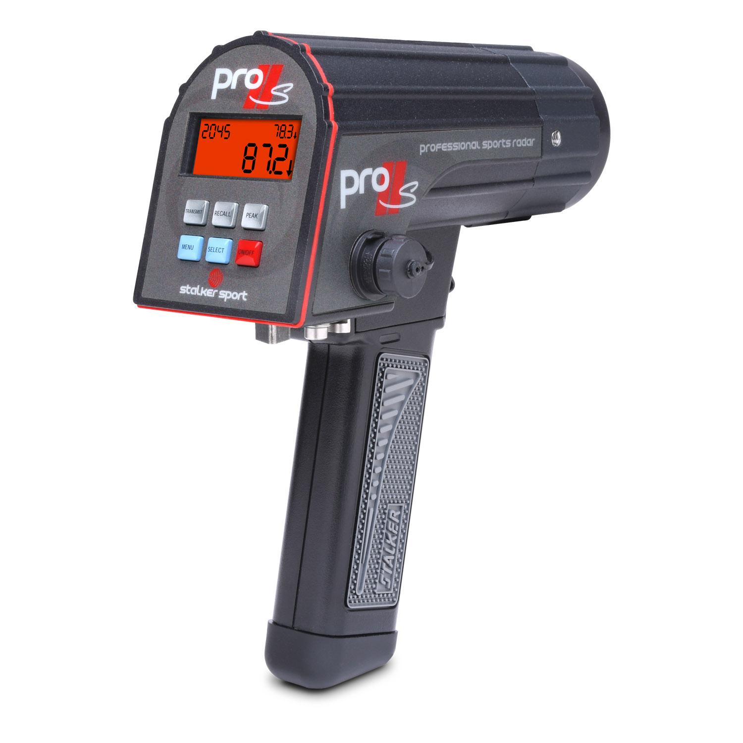
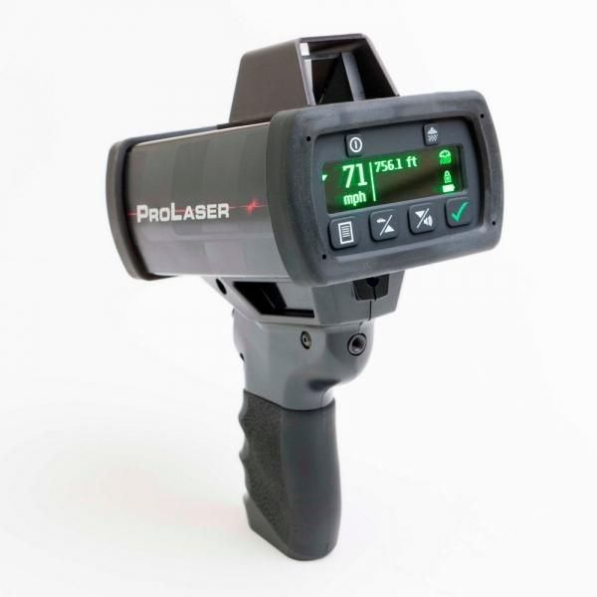
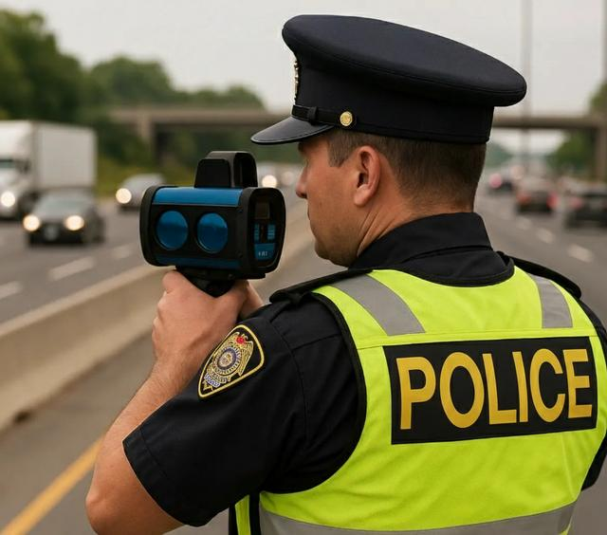
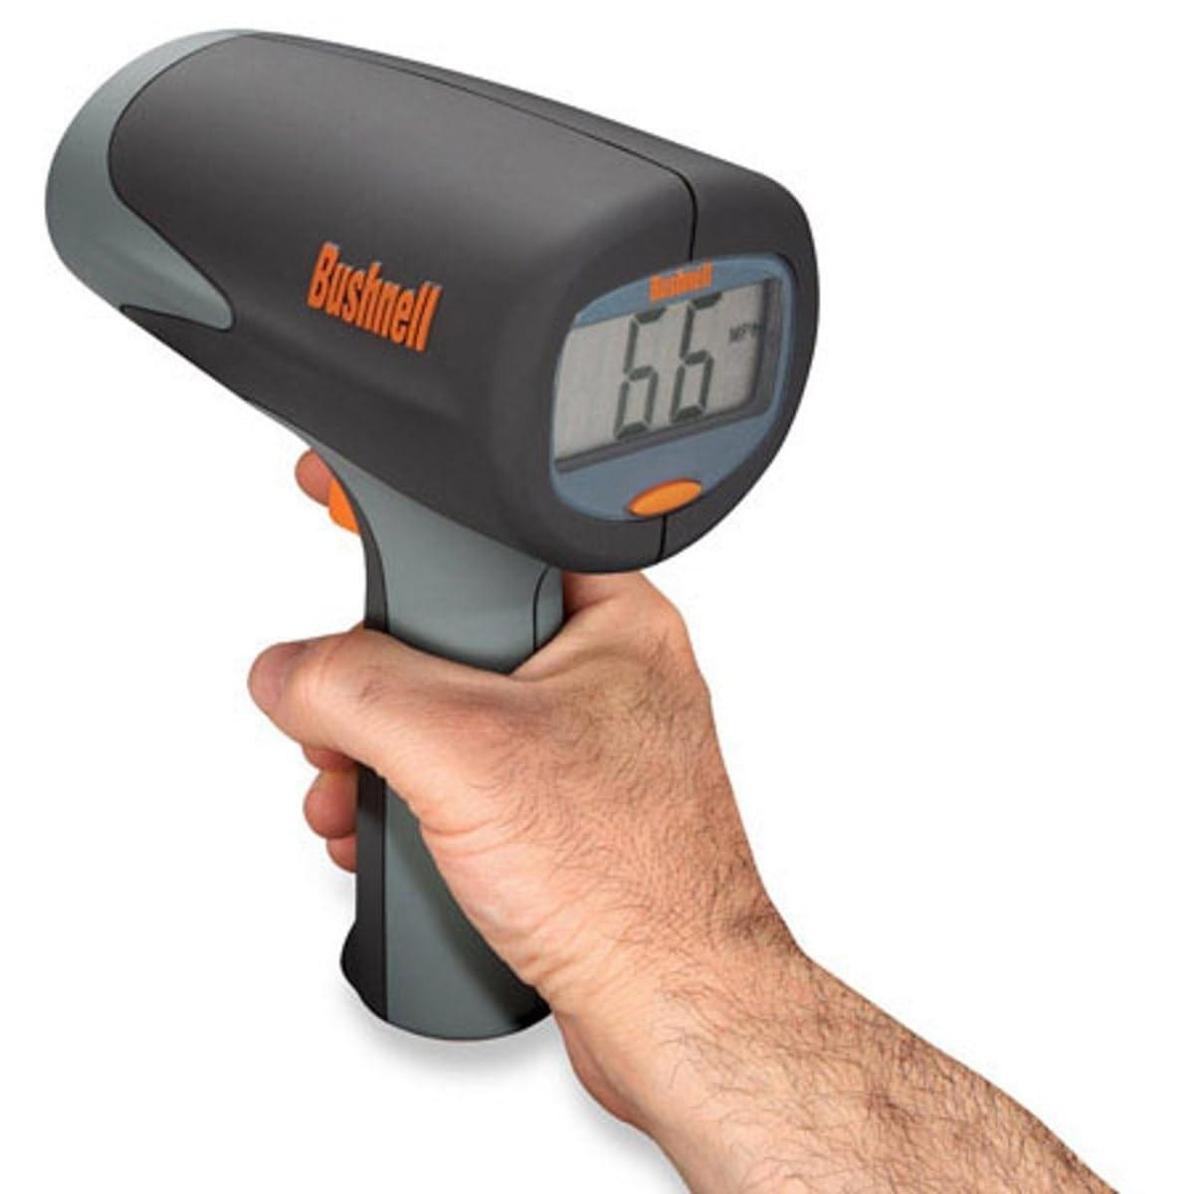
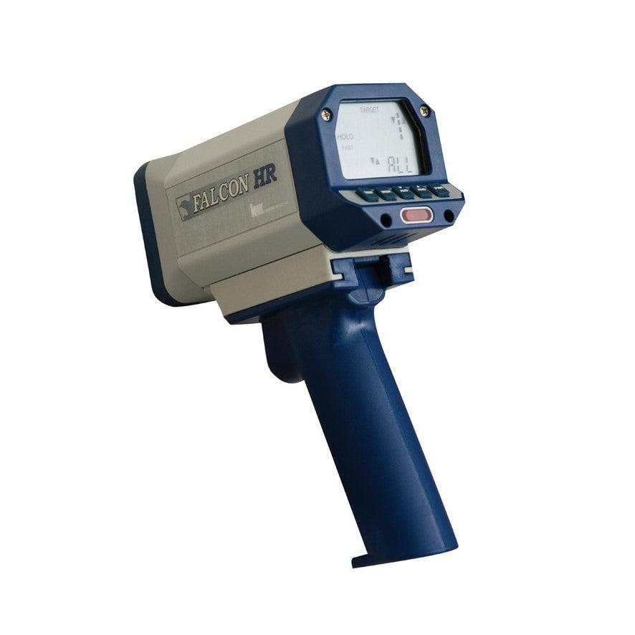
A Radar Speed Gun is a handheld electronic instrument that measures the speed of a moving object by transmitting radio waves and analyzing the reflected signal. It uses the Doppler Effect to determine how fast the object is moving toward or away from the device.
Radar speed guns are commonly used by traffic police, sports coaches, researchers, and industrial operators to measure the speed of vehicles, balls, athletes, and machinery.

Definition
# Source: AI Source: Provided by: [Data Path: Persons Table -> ID Column: 1, Name_En Column: Motasem Essam] -> From: [ChatGPT] on [7/17/2026]
A Radar Speed Gun is a speed-measuring instrument that uses radio-frequency radar waves and the Doppler Effect to determine the speed of a moving object.

Purpose
# Source: AI Source: Provided by: [Data Path: Persons Table -> ID Column: 1, Name_En Column: Motasem Essam] -> From: [ChatGPT] on [7/17/2026]
A radar speed gun is used to:
- Measure vehicle speed.
- Enforce traffic speed limits.
- Measure the speed of sports equipment.
- Monitor industrial machinery.
- Conduct research and testing.

Principle of Operation
# Source: AI Source: Provided by: [Data Path: Persons Table -> ID Column: 1, Name_En Column: Motasem Essam] -> From: [ChatGPT] on [7/17/2026]
The radar speed gun:
- Emits a microwave radio signal.
- The signal reflects from the moving object.
- The reflected signal returns with a frequency shift.
- The Doppler frequency shift is converted into speed.

Main Components
# Source: AI Source: Provided by: [Data Path: Persons Table -> ID Column: 1, Name_En Column: Motasem Essam] -> From: [ChatGPT] on [7/17/2026]
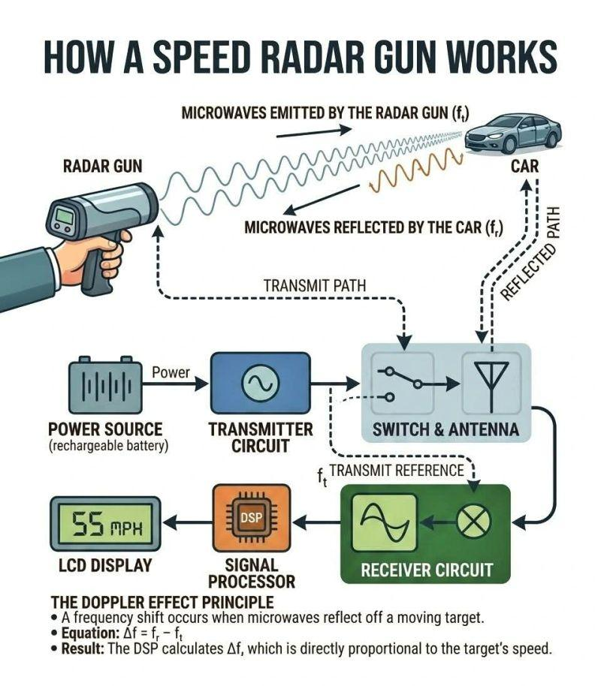
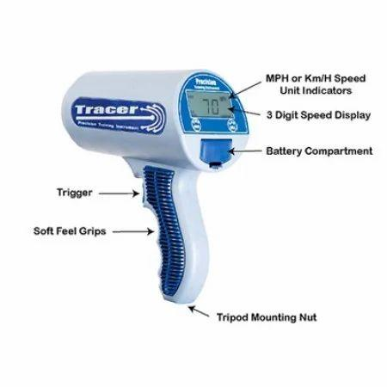
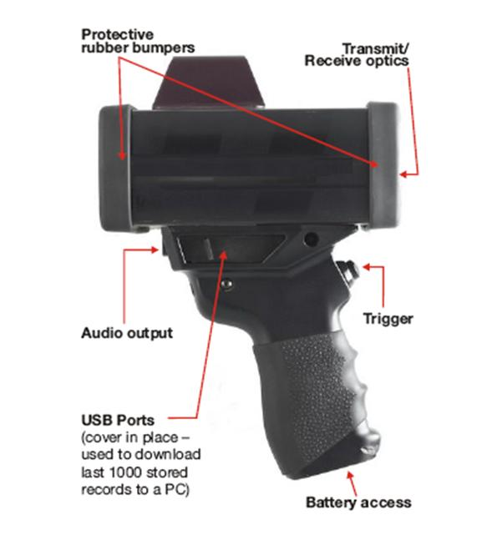
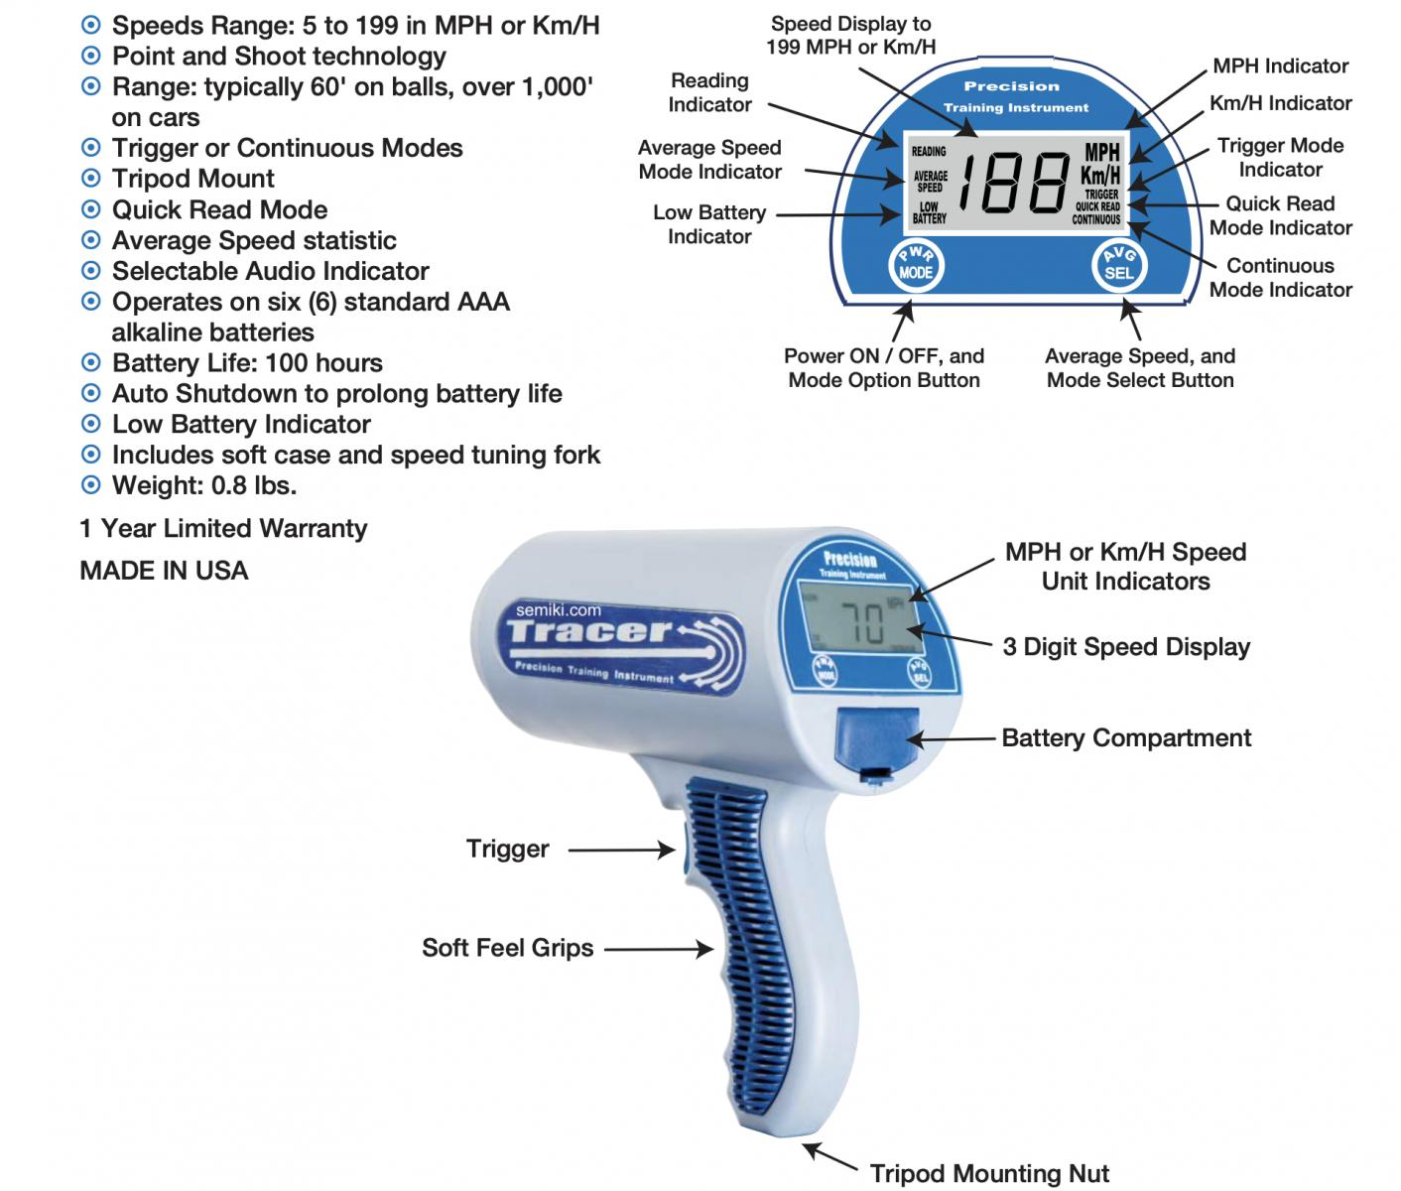
A radar speed gun typically consists of:
- Radar antenna
- Microwave transmitter
- Receiver
- Processor
- Digital display
- Trigger button
- Battery

Types of Radar Speed Guns

1. Traffic Radar Speed Gun
# Source: AI Source: Provided by: [Data Path: Persons Table -> ID Column: 1, Name_En Column: Motasem Essam] -> From: [ChatGPT] on [7/17/2026]
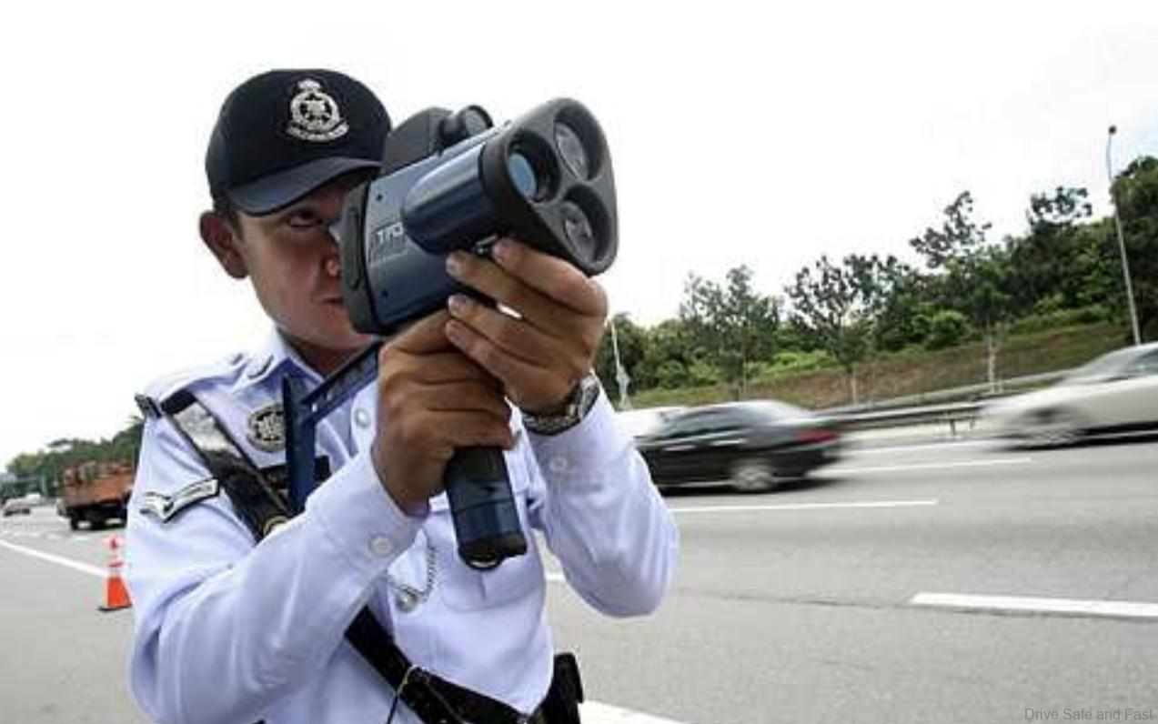
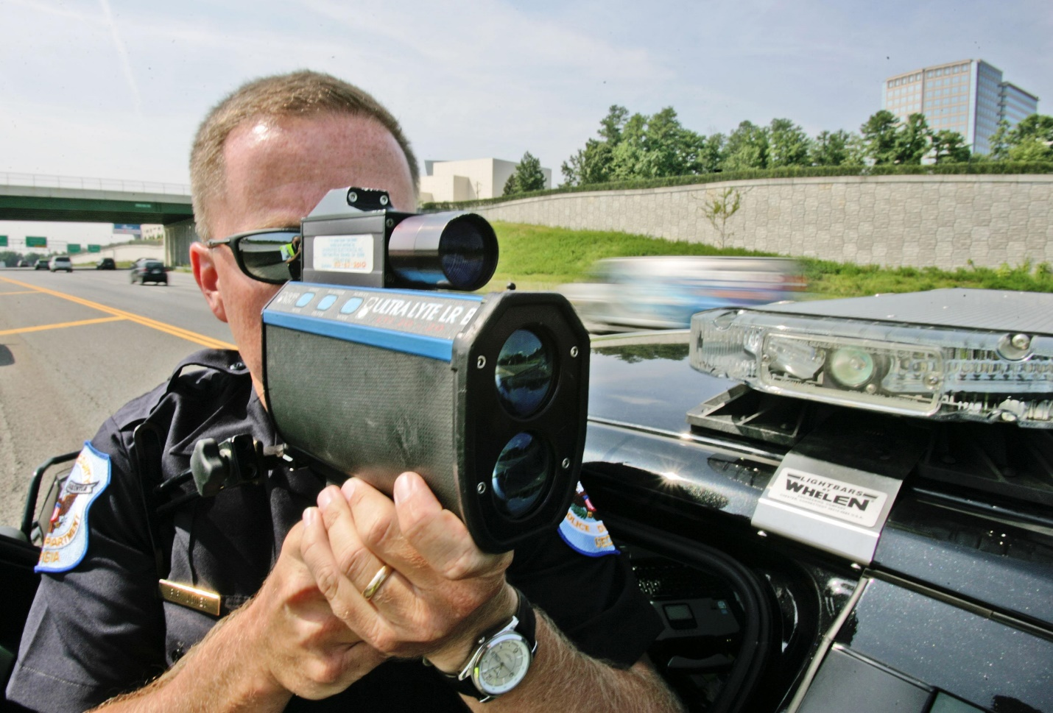
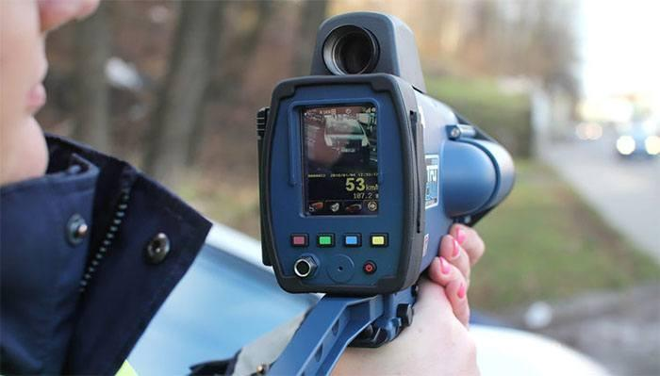
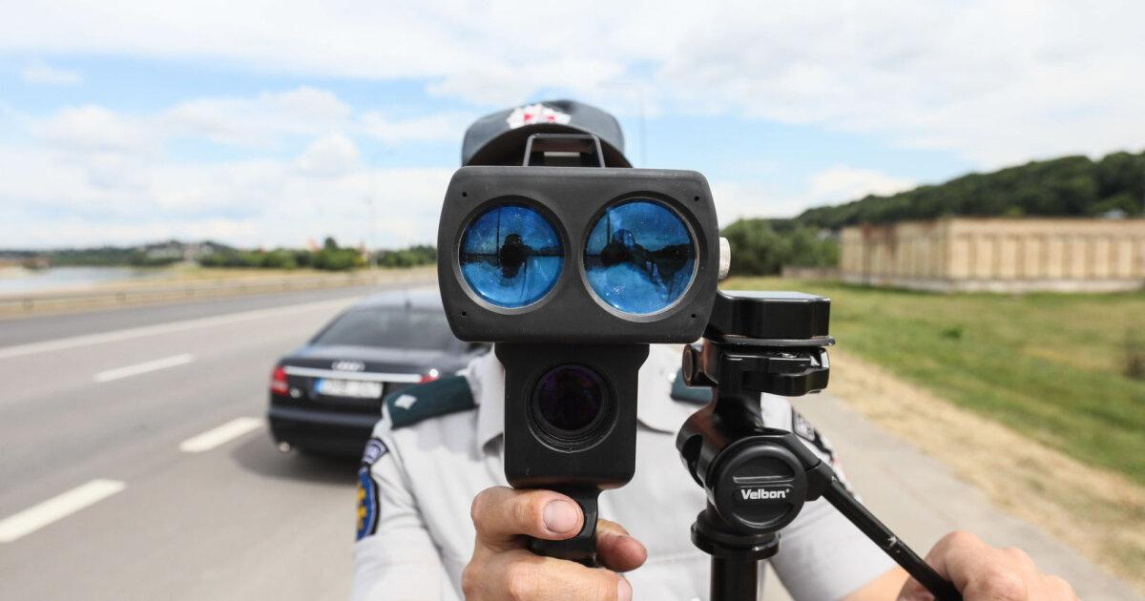
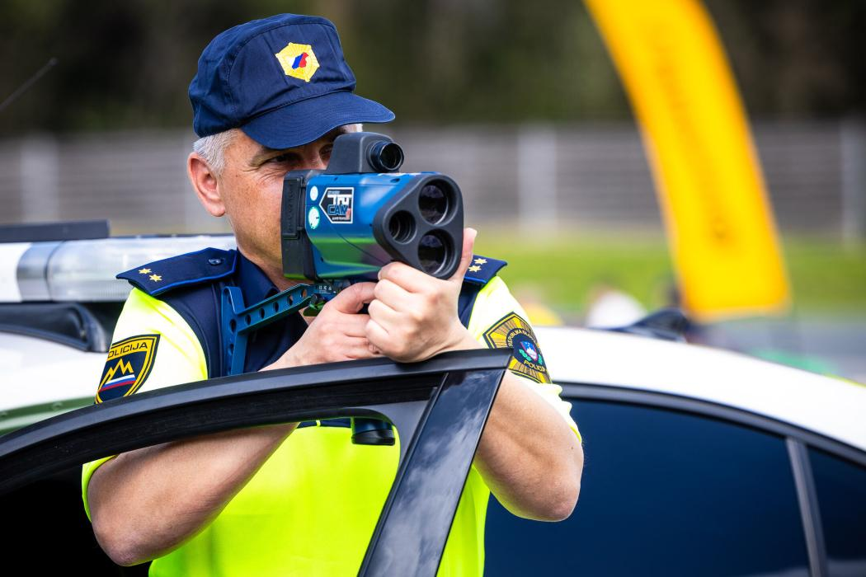
Description
Designed for law enforcement to measure vehicle speed.
Applications
- Traffic enforcement
- Highway patrol
- Road safety monitoring

2. Sports Radar Gun
# Source: AI Source: Provided by: [Data Path: Persons Table -> ID Column: 1, Name_En Column: Motasem Essam] -> From: [ChatGPT] on [7/17/2026]
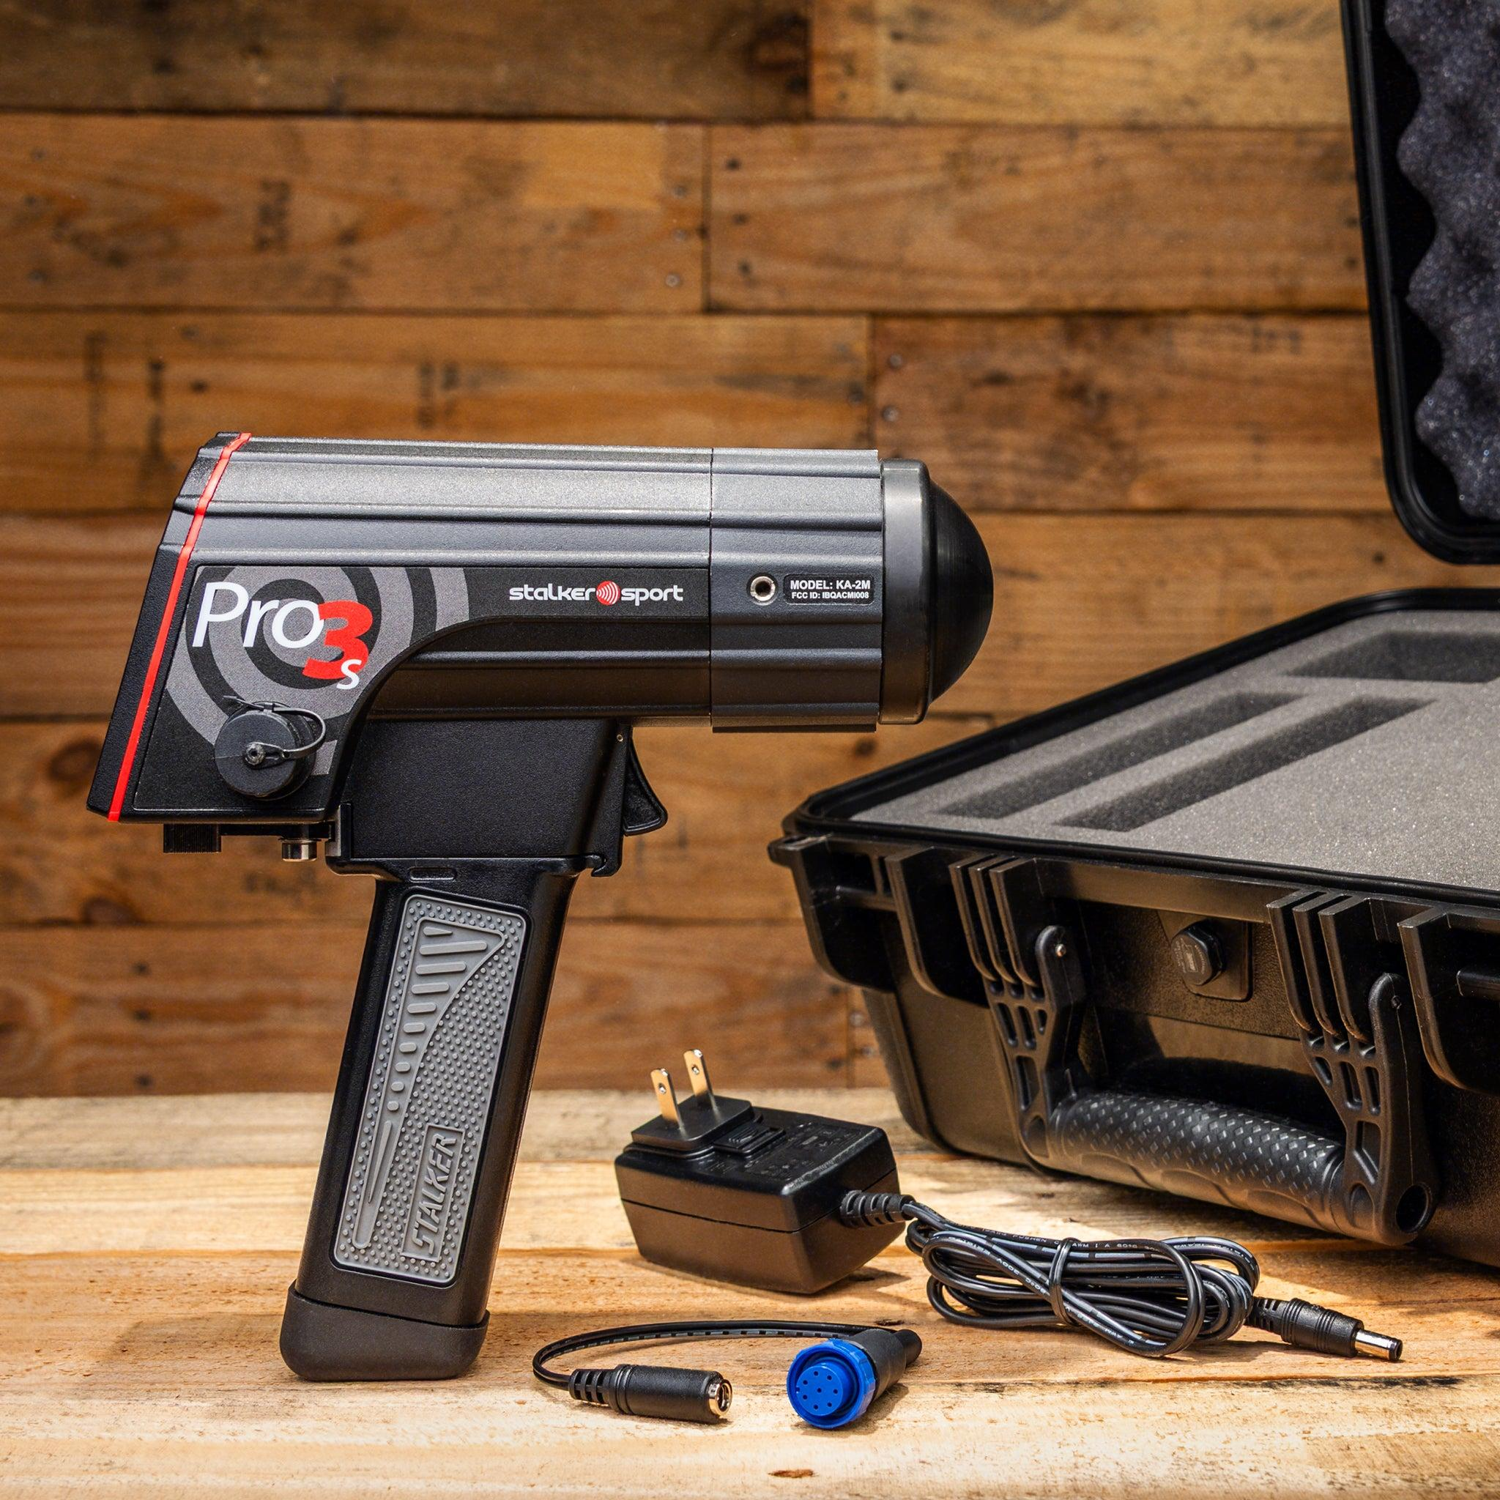
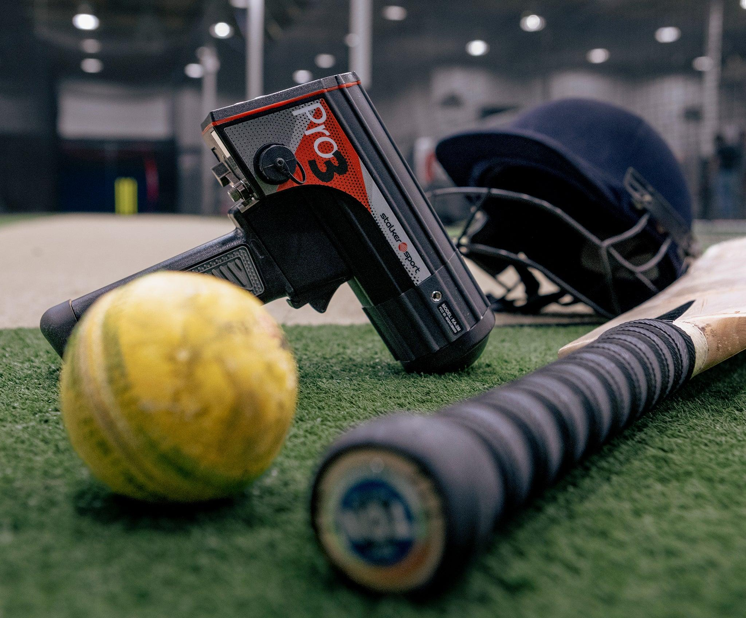
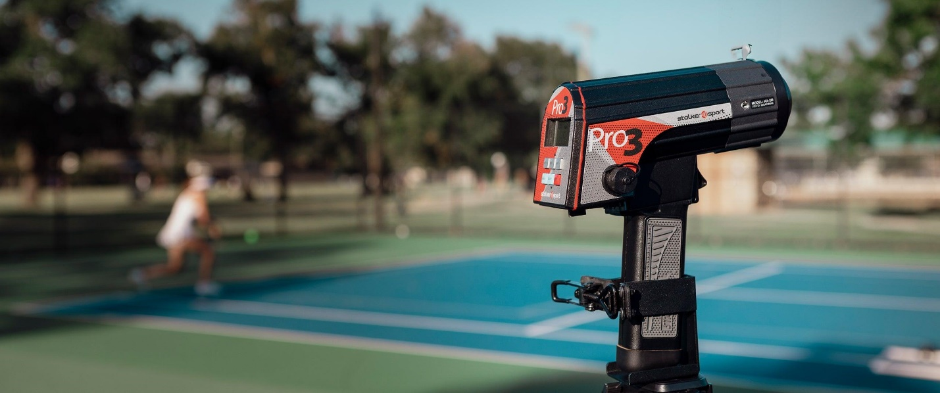
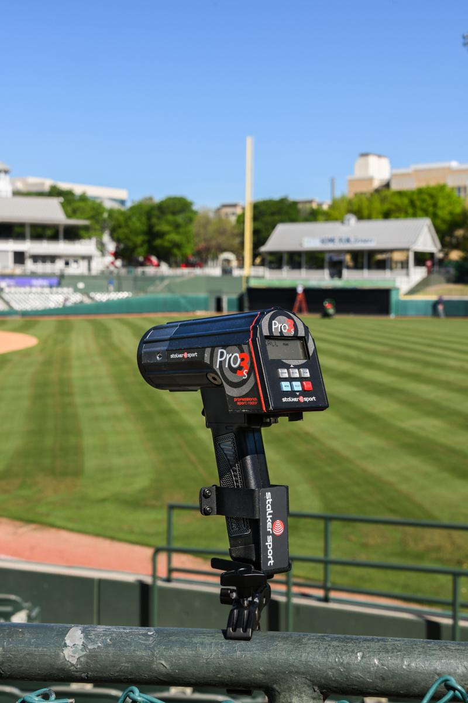
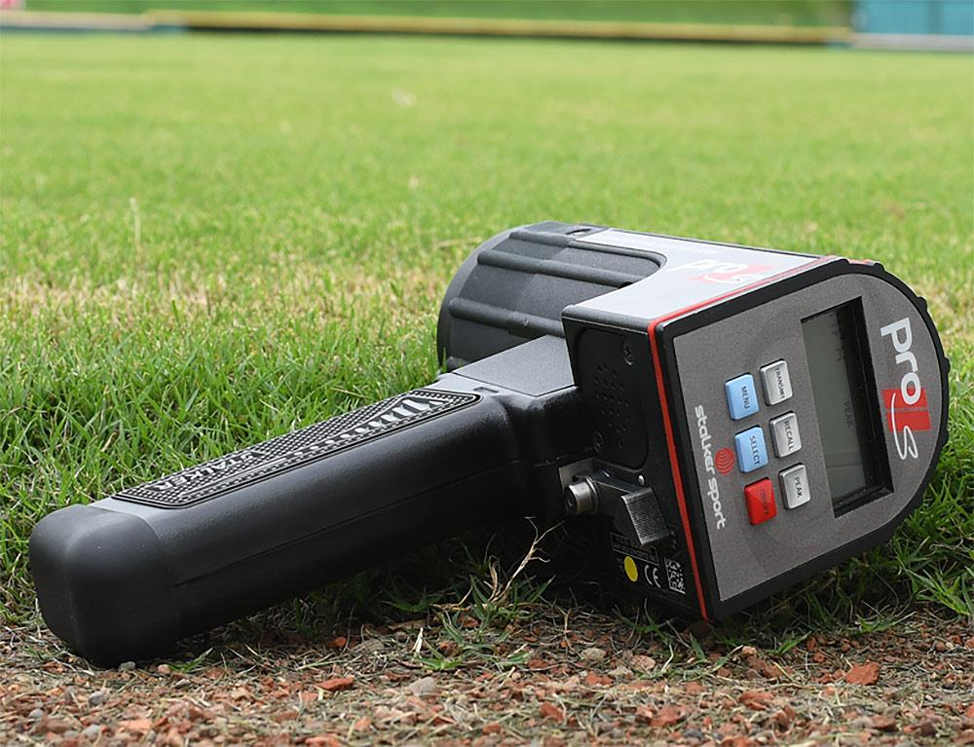
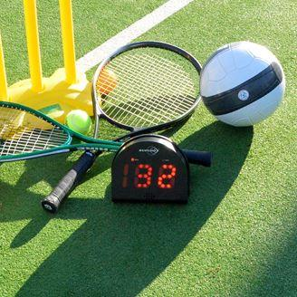
Description
Measures the speed of balls, players, and sports equipment.
Applications
- Baseball
- Cricket
- Tennis
- Golf
- Athletics

3. Industrial Radar Speed Gun
# Source: AI Source: Provided by: [Data Path: Persons Table -> ID Column: 1, Name_En Column: Motasem Essam] -> From: [ChatGPT] on [7/17/2026]
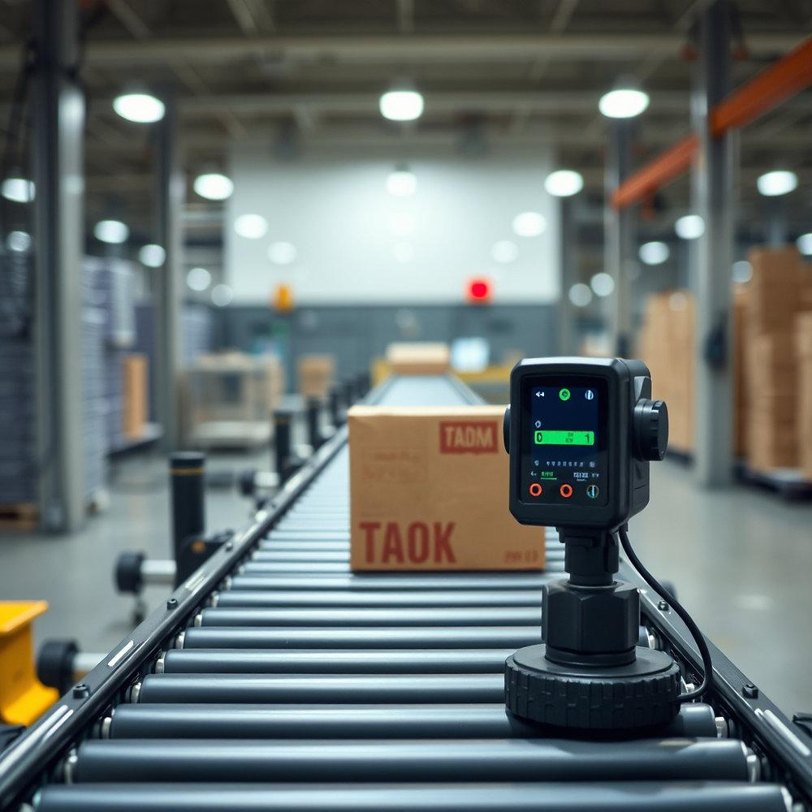
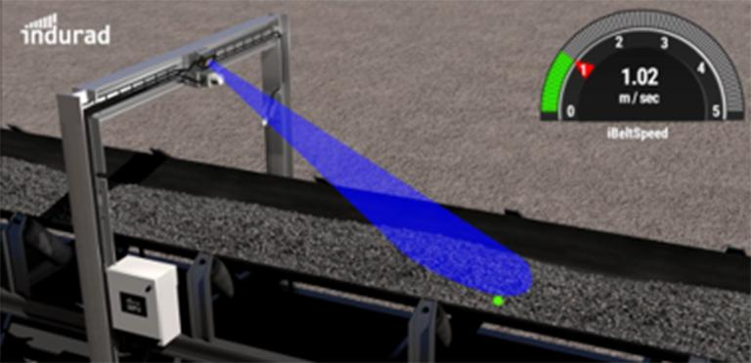
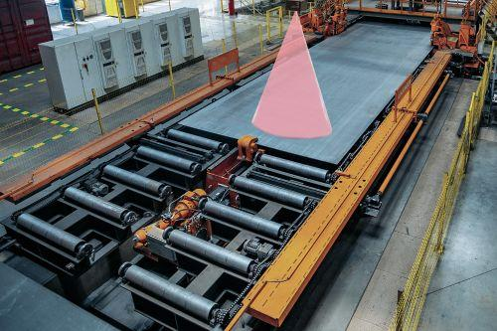
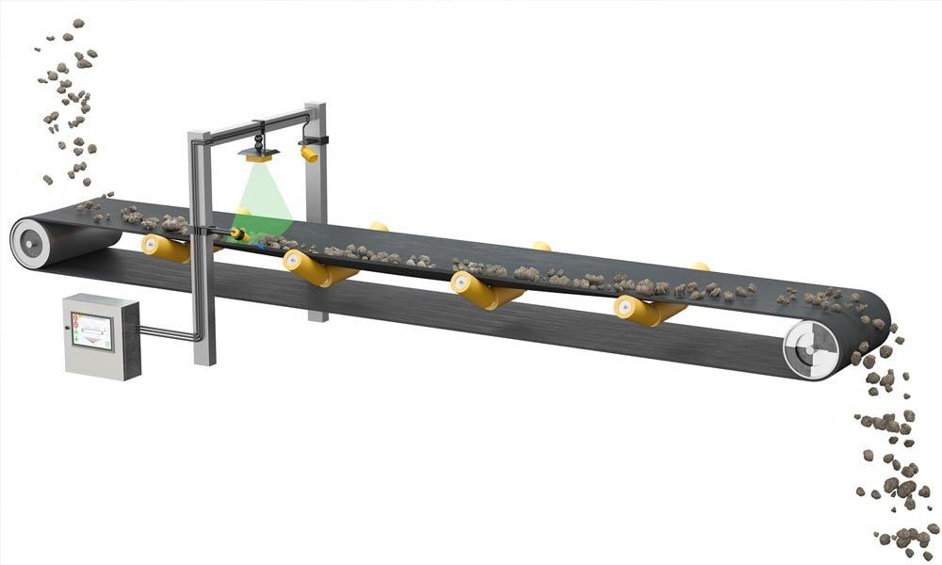
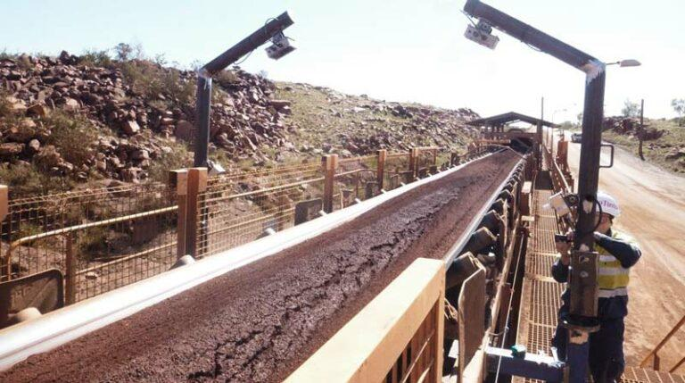
Description
Used to monitor the speed of moving machinery or production equipment.
Applications
- Conveyor belts
- Manufacturing
- Material handling

4. Portable Handheld Radar Gun
# Source: AI Source: Provided by: [Data Path: Persons Table -> ID Column: 1, Name_En Column: Motasem Essam] -> From: [ChatGPT] on [7/17/2026]
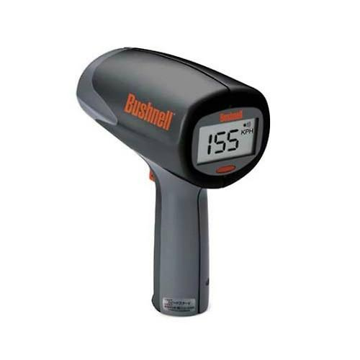

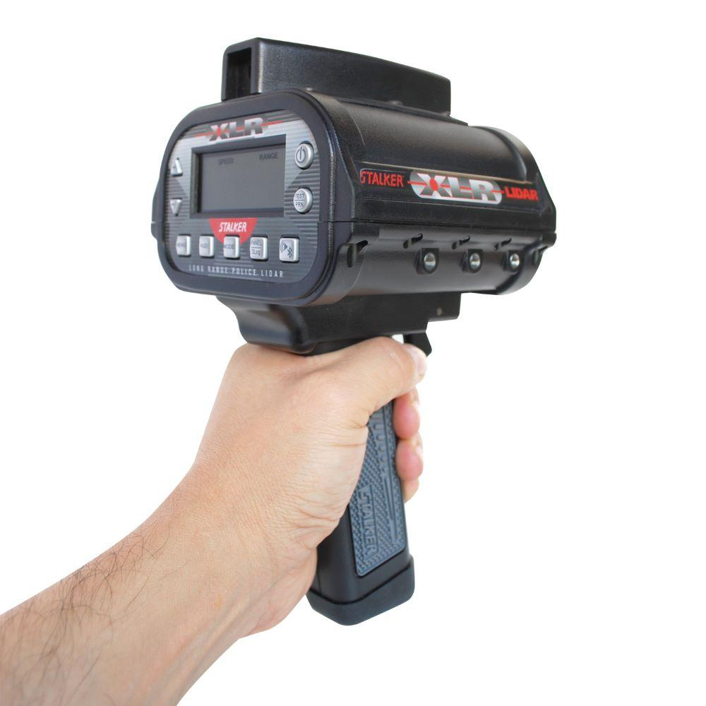
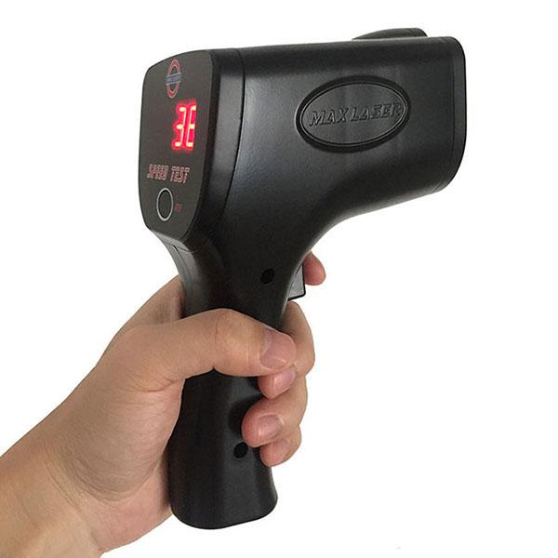

Description
Compact radar gun suitable for field measurements.
Applications
- Education
- Research
- Outdoor testing
- Sports

Measuring Units
# Source: AI Source: Provided by: [Data Path: Persons Table -> ID Column: 1, Name_En Column: Motasem Essam] -> From: [ChatGPT] on [7/17/2026]
Radar speed guns commonly display speed in:
- Kilometers per hour (km/h)
- Miles per hour (mph)
- Meters per second (m/s)

Measuring Range
# Source: AI Source: Provided by: [Data Path: Persons Table -> ID Column: 1, Name_En Column: Motasem Essam] -> From: [ChatGPT] on [7/17/2026]
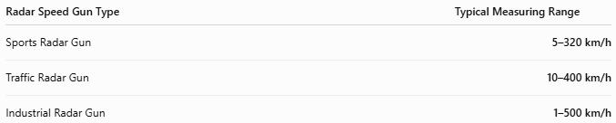
Radar Speed Gun Type | Typical Measuring Range
Sports Radar Gun | 5–320 km/h
Traffic Radar Gun | 10–400 km/h
Industrial Radar Gun | 1–500 km/h

Resolution
# Source: AI Source: Provided by: [Data Path: Persons Table -> ID Column: 1, Name_En Column: Motasem Essam] -> From: [ChatGPT] on [7/17/2026]
Resolution is the smallest speed increment displayed.
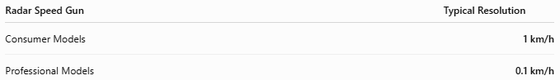
Radar Speed Gun | Typical Resolution
Consumer Models | 1 km/h
Professional Models | 0.1 km/h

Accuracy
# Source: AI Source: Provided by: [Data Path: Persons Table -> ID Column: 1, Name_En Column: Motasem Essam] -> From: [ChatGPT] on [7/17/2026]
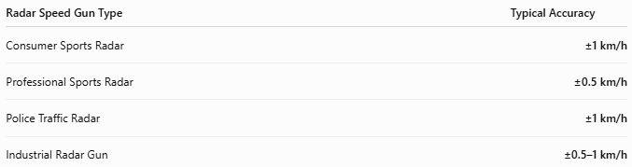
Radar Speed Gun Type | Typical Accuracy
Consumer Sports Radar | ±1 km/h
Professional Sports Radar | ±0.5 km/h
Police Traffic Radar | ±1 km/h
Industrial Radar Gun | ±0.5–1 km/h
Notes
- Accuracy depends on the angle between the radar beam and the moving object.
- Maximum accuracy is achieved when the radar beam is aligned directly with the object's direction of travel.
- Weather and nearby reflective objects can slightly affect readings.

How to Use a Radar Speed Gun
# Source: AI Source: Provided by: [Data Path: Persons Table -> ID Column: 1, Name_En Column: Motasem Essam] -> From: [ChatGPT] on [7/17/2026]
- Turn on the device.
- Aim the radar beam at the moving object.
- Pull and hold the trigger.
- Read the speed displayed on the screen.
- Release the trigger to stop measurement.

Applications
# Source: AI Source: Provided by: [Data Path: Persons Table -> ID Column: 1, Name_En Column: Motasem Essam] -> From: [ChatGPT] on [7/17/2026]
Radar speed guns are used in:
- Traffic law enforcement
- Sports performance analysis
- Vehicle testing
- Industrial monitoring
- Scientific research
- Education

Advantages
# Source: AI Source: Provided by: [Data Path: Persons Table -> ID Column: 1, Name_En Column: Motasem Essam] -> From: [ChatGPT] on [7/17/2026]
A radar speed gun:
- Provides non-contact speed measurement.
- Delivers instant readings.
- Has long measurement range.
- Is easy to operate.
- Works in daylight and at night.

Limitations
# Source: AI Source: Provided by: [Data Path: Persons Table -> ID Column: 1, Name_En Column: Motasem Essam] -> From: [ChatGPT] on [7/17/2026]
A radar speed gun:
- Measures only objects within the radar beam.
- Accuracy decreases if the beam is not aligned with the object's motion (cosine error).
- Can detect unintended nearby objects.
- May experience interference from reflective surfaces.

Sources of Error
# Source: AI Source: Provided by: [Data Path: Persons Table -> ID Column: 1, Name_En Column: Motasem Essam] -> From: [ChatGPT] on [7/17/2026]
Instrument Errors
- Battery depletion
- Internal calibration drift
- Damaged antenna

User Errors
- Poor aiming
- Incorrect measurement angle
- Tracking the wrong object

Environmental Errors
- Heavy rain
- Snow
- Large reflective objects
- Electromagnetic interference

Comparison with Other Speed Measuring Instruments
# Source: AI Source: Provided by: [Data Path: Persons Table -> ID Column: 1, Name_En Column: Motasem Essam] -> From: [ChatGPT] on [7/17/2026]
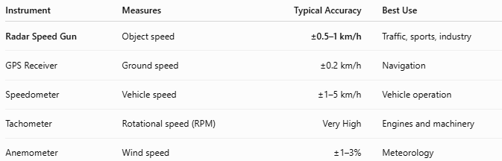
Instrument | Measures | Typical Accuracy | Best Use
Radar Speed Gun | Object speed | ±0.5–1 km/h | Traffic, sports, industry
GPS Receiver | Ground speed | ±0.2 km/h | Navigation
Speedometer | Vehicle speed | ±1–5 km/h | Vehicle operation
Tachometer | Rotational speed (RPM) | Very High | Engines and machinery
Anemometer | Wind speed | ±1–3% | Meteorology

Care and Maintenance
# Source: AI Source: Provided by: [Data Path: Persons Table -> ID Column: 1, Name_En Column: Motasem Essam] -> From: [ChatGPT] on [7/17/2026]
To maintain performance:
- Keep the radar lens clean.
- Replace or recharge batteries regularly.
- Store in a protective case.
- Avoid dropping the device.
- Perform periodic calibration according to the manufacturer's recommendations.

Common Mistakes
# Source: AI Source: Provided by: [Data Path: Persons Table -> ID Column: 1, Name_En Column: Motasem Essam] -> From: [ChatGPT] on [7/17/2026]
- Measuring at a large angle to the target.
- Tracking the wrong moving object.
- Ignoring interference from nearby vehicles.
- Using the device without proper calibration.

Key Points
# Source: AI Source: Provided by: [Data Path: Persons Table -> ID Column: 1, Name_En Column: Motasem Essam] -> From: [ChatGPT] on [7/17/2026]
- A Radar Speed Gun measures speed using radio waves.
- It operates based on the Doppler Effect.
- Common types:
  - Traffic Radar Speed Gun
  - Sports Radar Gun
  - Industrial Radar Speed Gun
  - Portable Handheld Radar Gun
- Widely used in traffic enforcement, sports, industry, and research.

Conclusion
# Source: AI Source: Provided by: [Data Path: Persons Table -> ID Column: 1, Name_En Column: Motasem Essam] -> From: [ChatGPT] on [7/17/2026]
A Radar Speed Gun is a fast, accurate, and non-contact speed-measuring instrument that determines the speed of moving objects using the Doppler Effect. Its ability to provide instant measurements over long distances makes it an essential tool for traffic law enforcement, sports performance analysis, industrial monitoring, scientific research, and vehicle testing.

